**COVIVOR – The survival of virus hunters**

The game COVIVOR stands for COVID SURVIVOR. It is a free game that simulates the real-world situation of a COVID-19 pandemic. In this game, the user will be able to understand how these viruses are dangerous to people’s health. The aim of this mobile game is to educate children age of 10 and above on how they can protect themselves against the deadly monster virus. The users may utilize the given items: face mask, face shield, sanitizer, and vaccine dependent on its prescribe usage in order to survive. At the end of the game, the users will be asked a variety of questions based on what they have learned about the game.

**Game Logo**

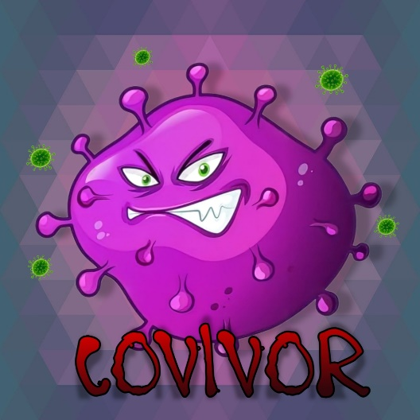

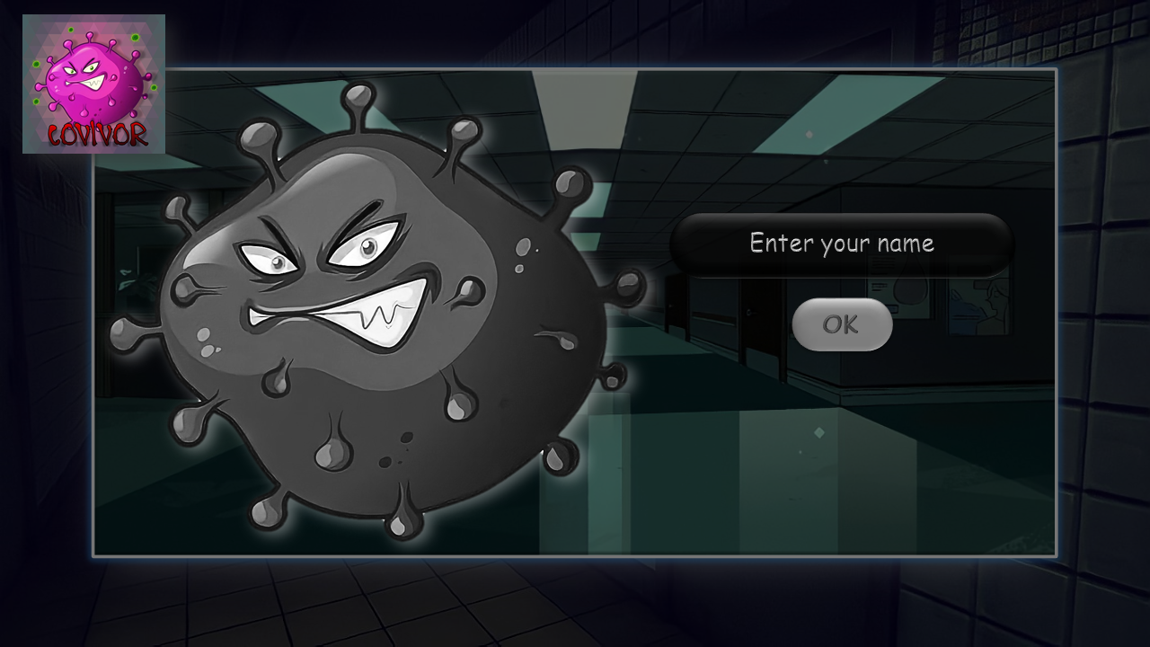**Username Setup**

**Character Selection**

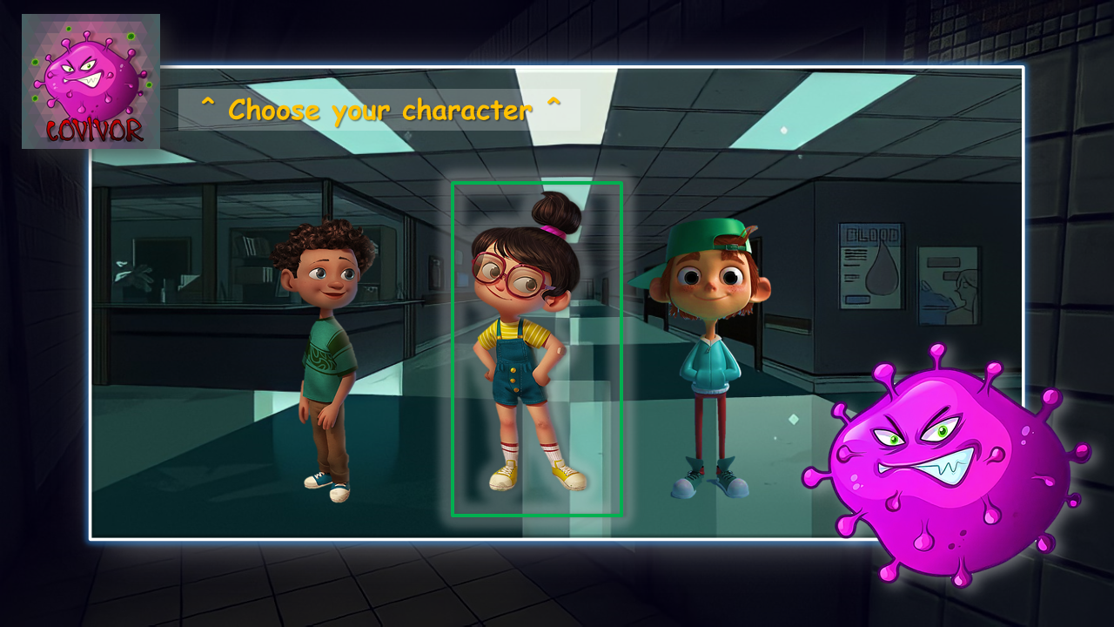

**Character Customization**

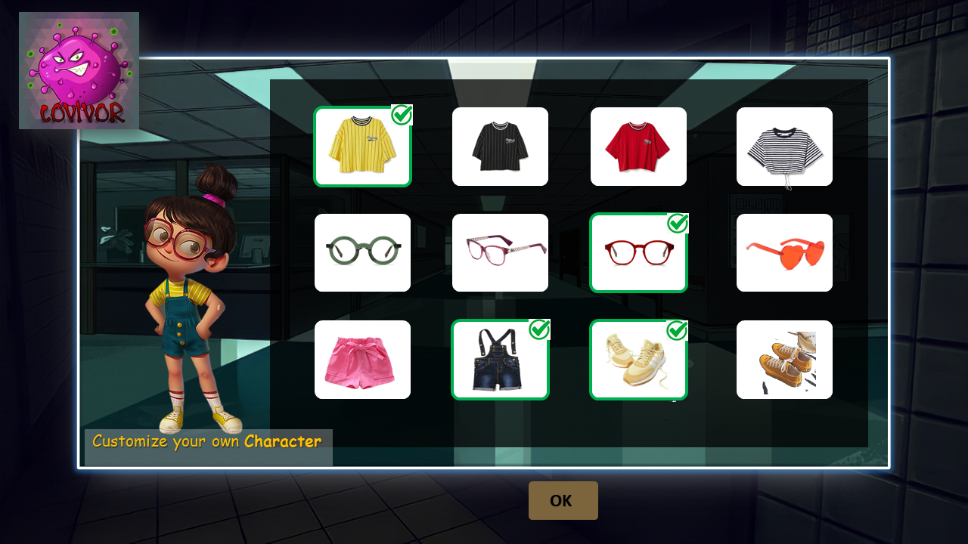

**Instructions**

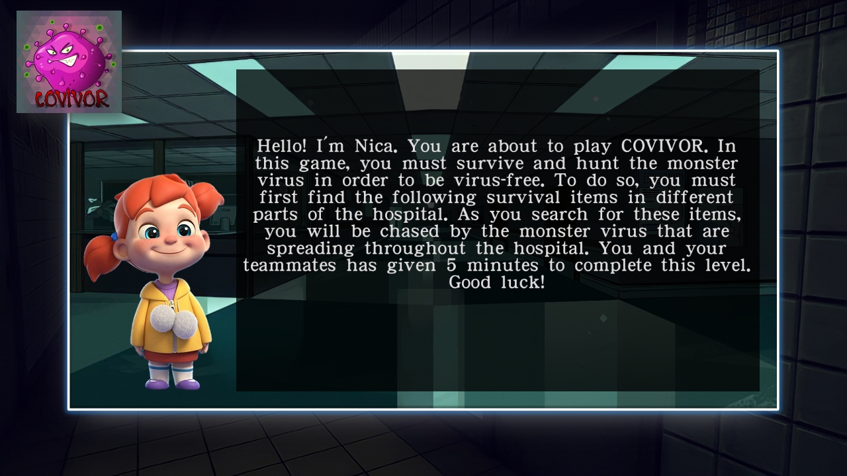

**OK**

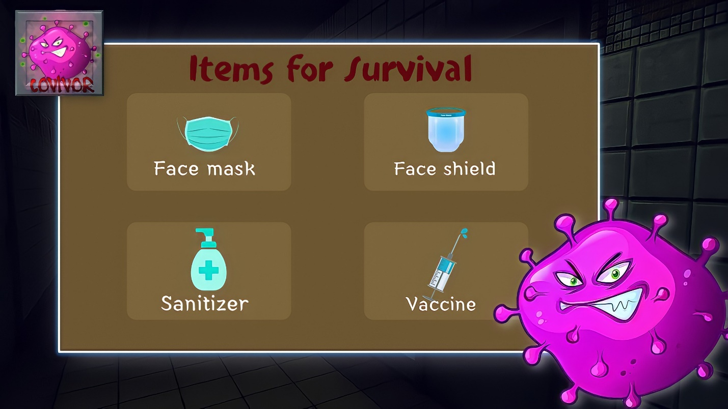**Survival Items**

**LEVEL 1: Beginning of the Game: Obtaining Survival Items**



**LEVEL 1**

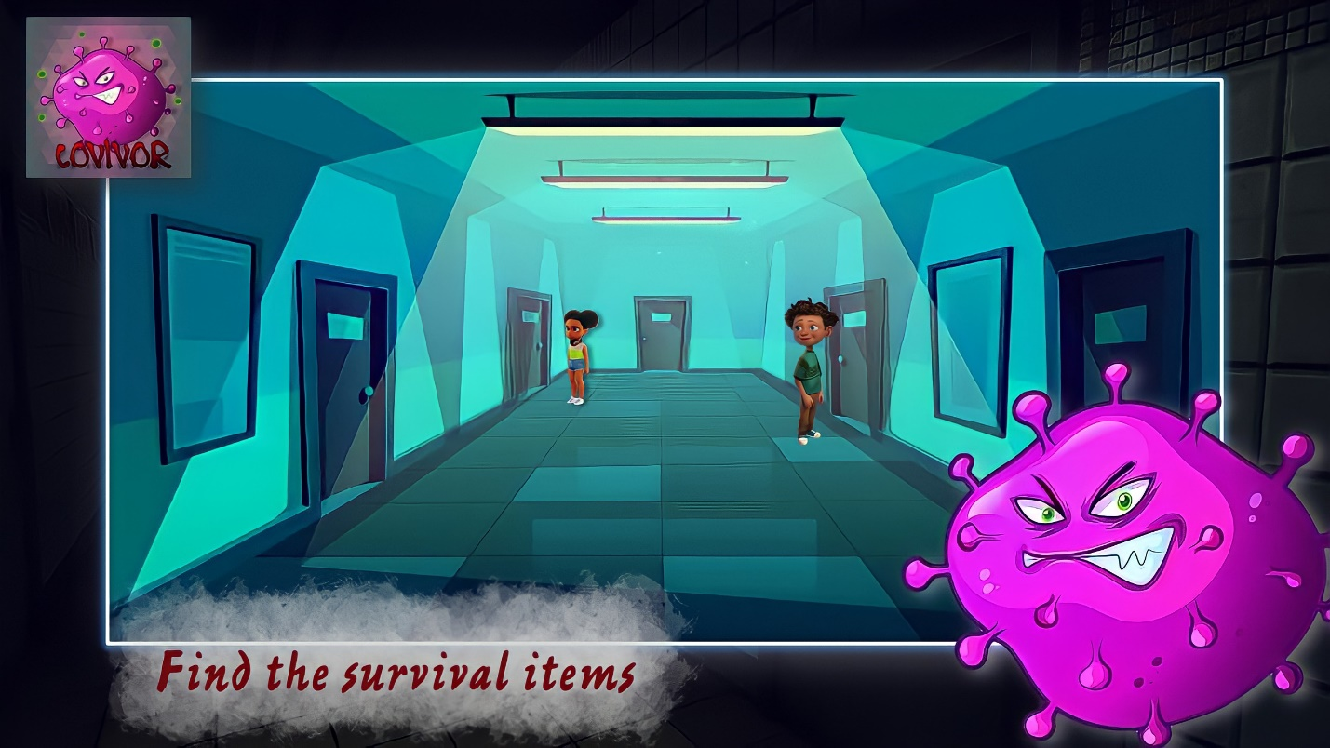

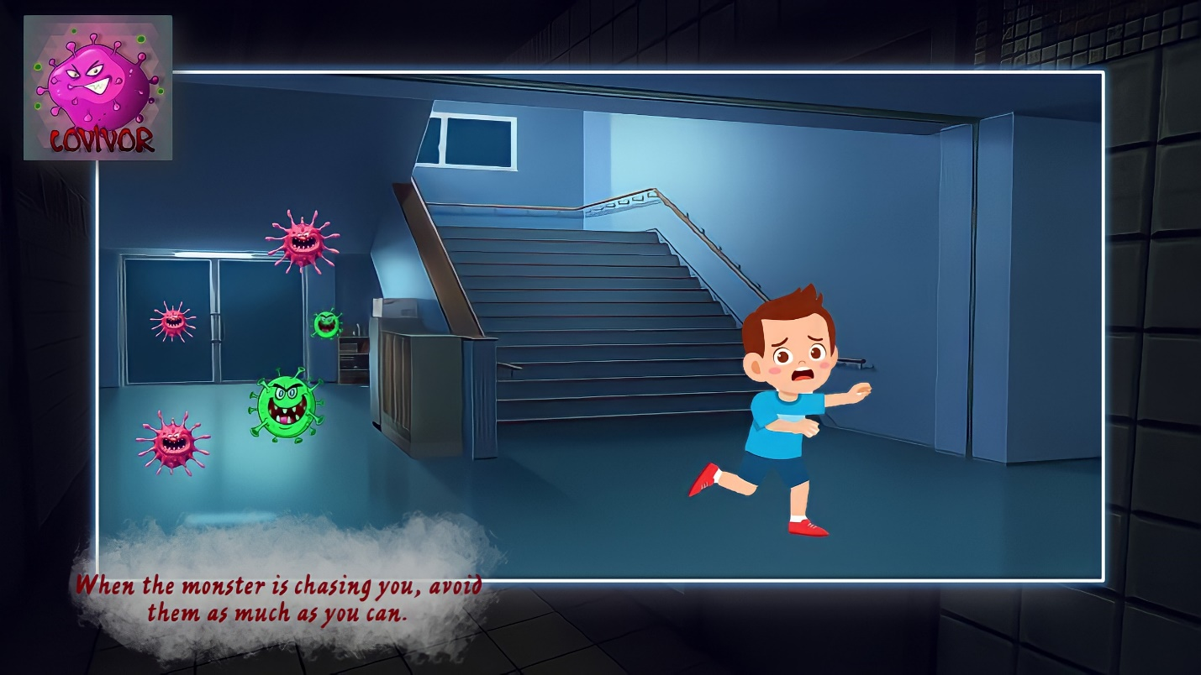**LEVEL 2: Obstacle and Challenges**



**LEVEL 2**

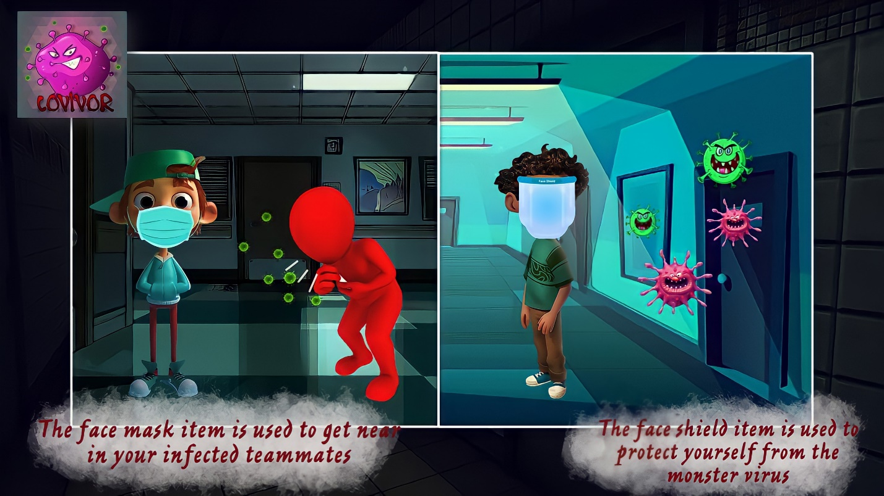**LEVEL 2: Usage of the Survival Items**



**LEVEL 2**

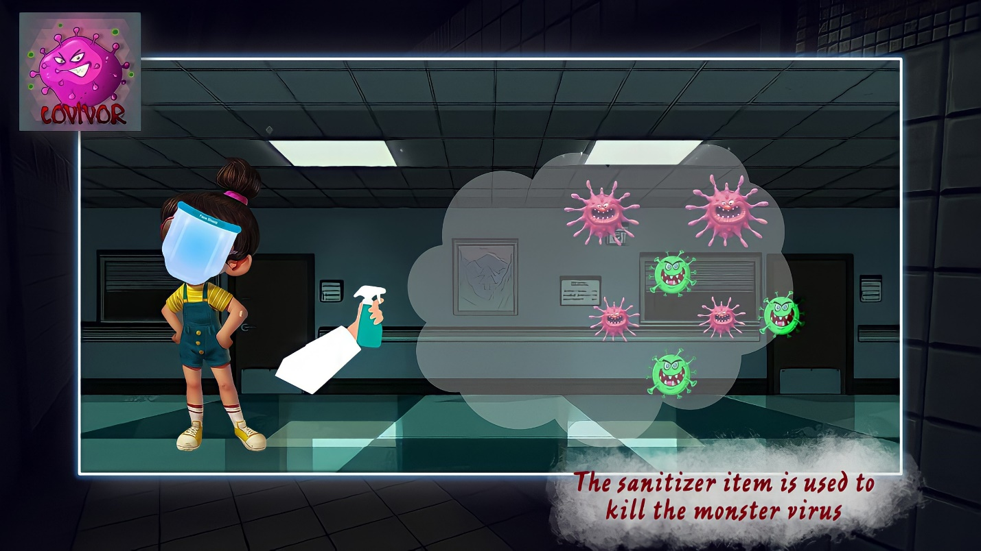

**LEVEL 2**



**LEVEL 2**

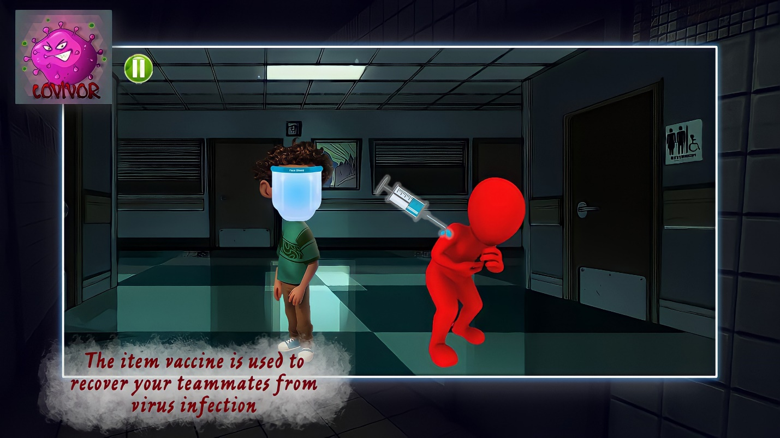

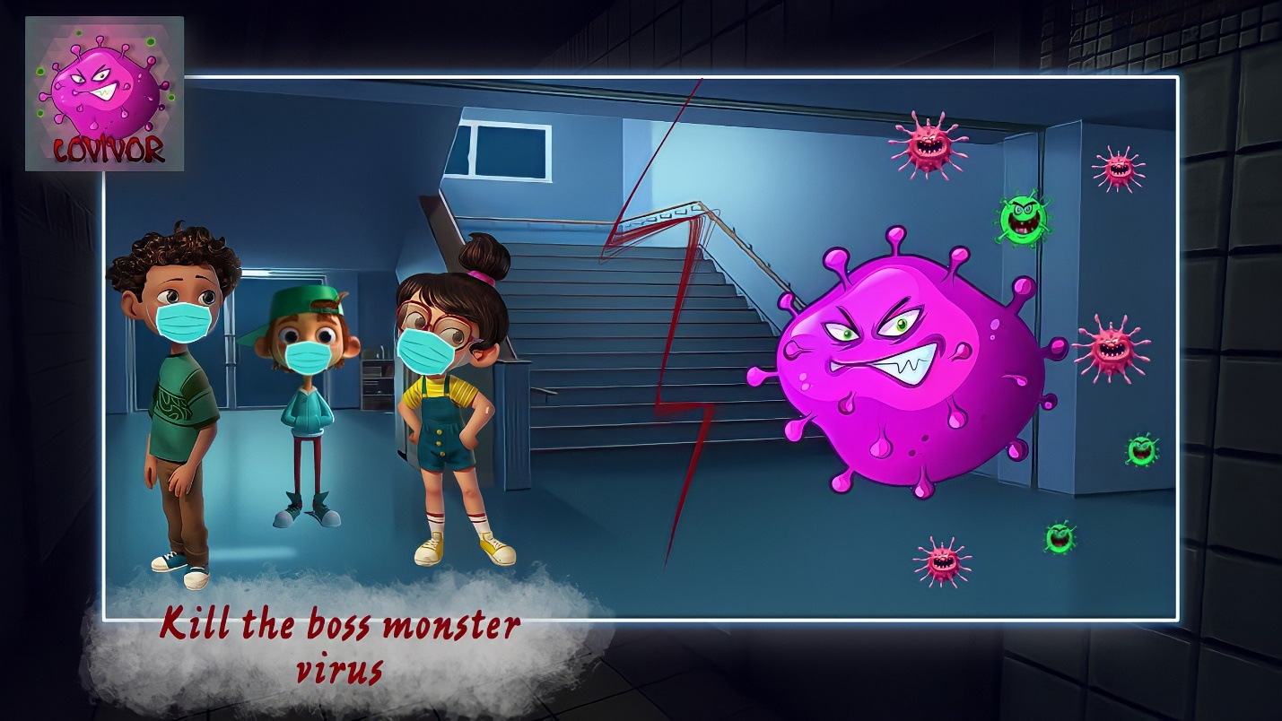**LEVEL 3: Execute the Boss Monster Virus**



**LEVEL 3**

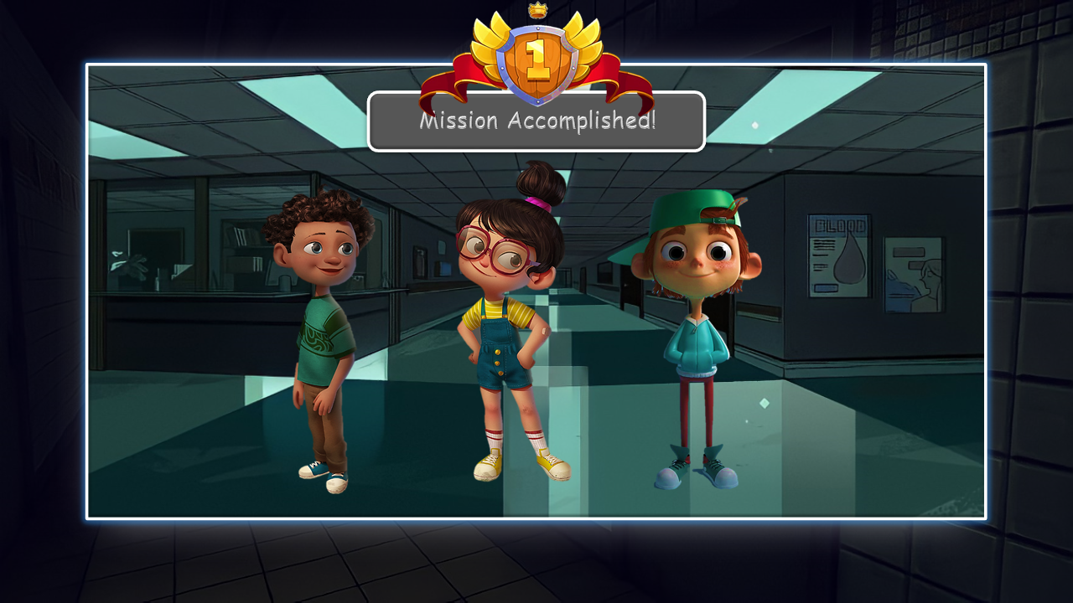**End of the Game**

**THINK QUIZ: Answer the quiz to earn extra coins**

**NEXT**

****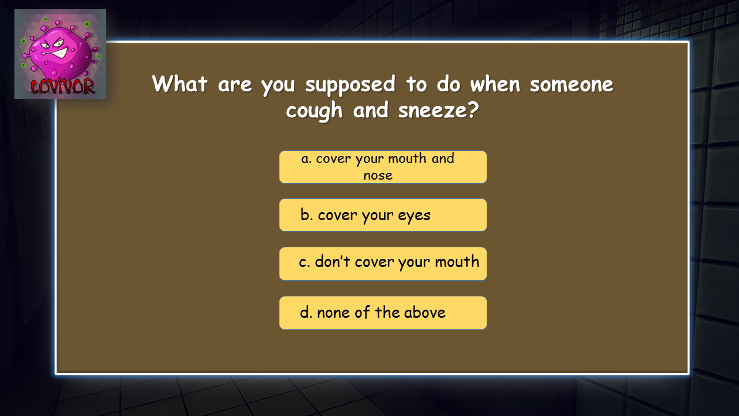

**NEXT**

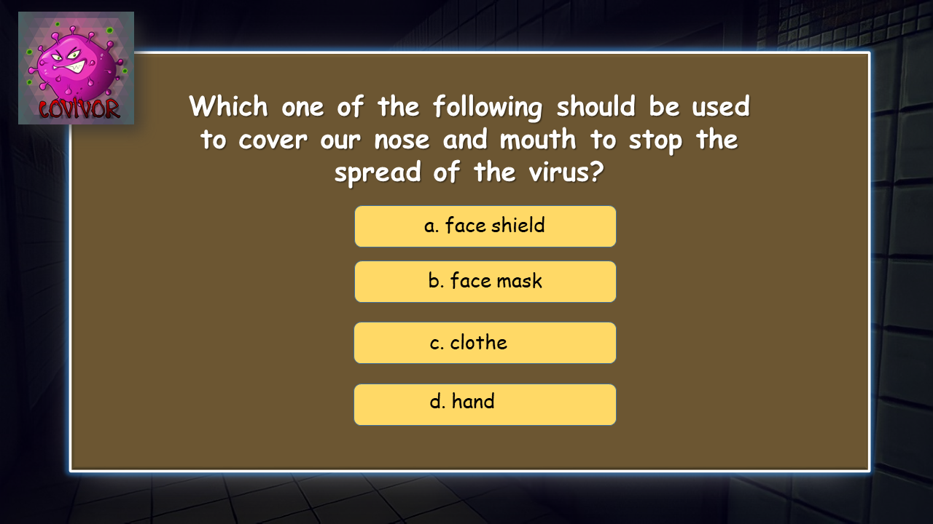

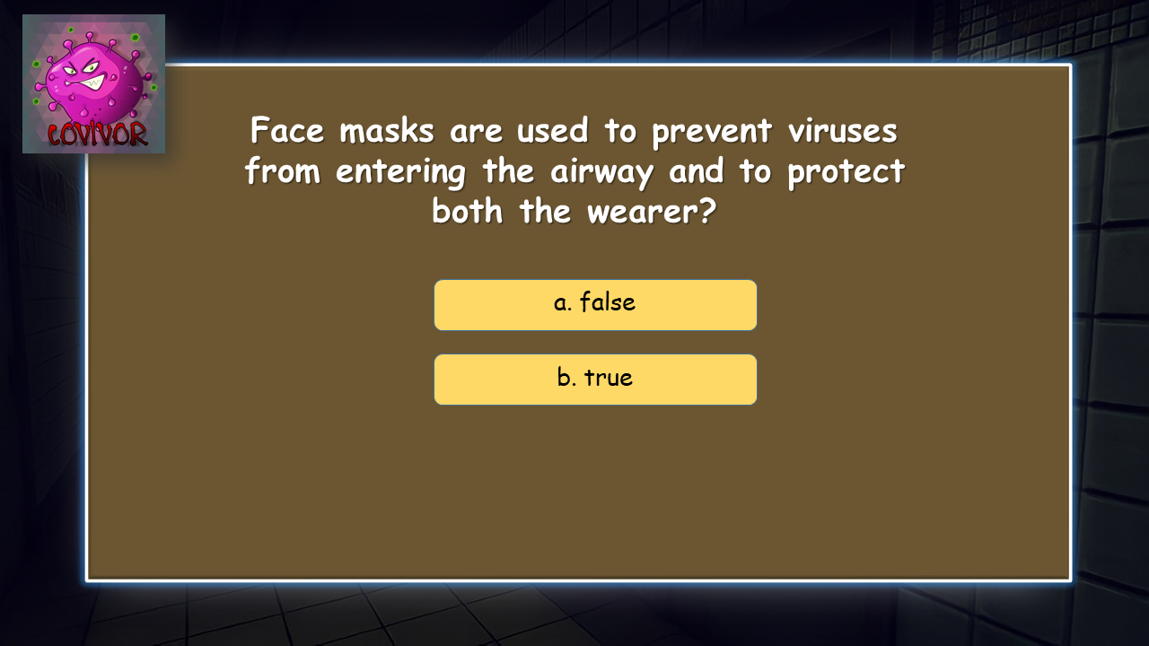

**NEXT**

**NEXT**

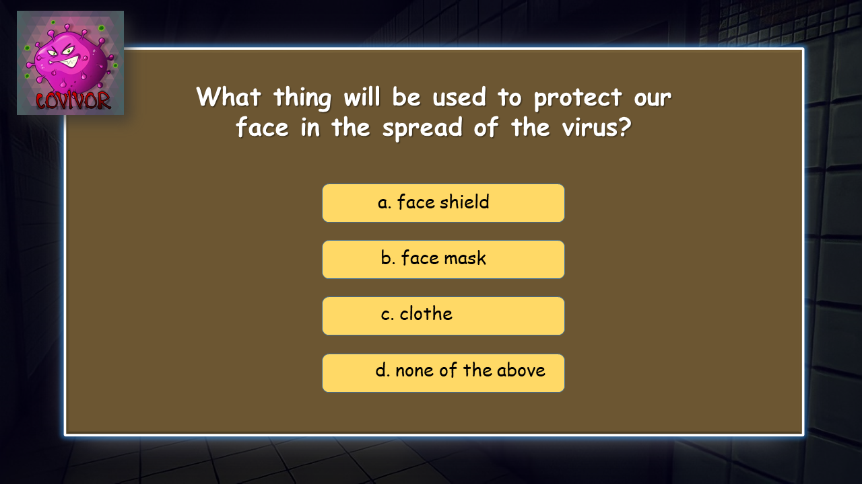

**NEXT**

****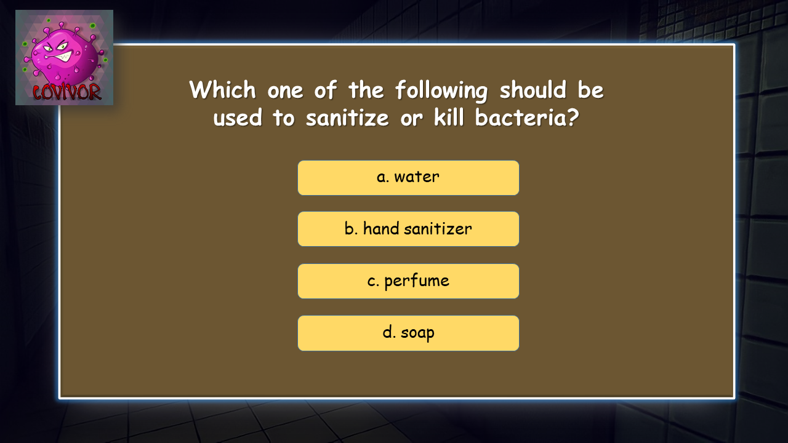

**NEXT**

**NEXT**

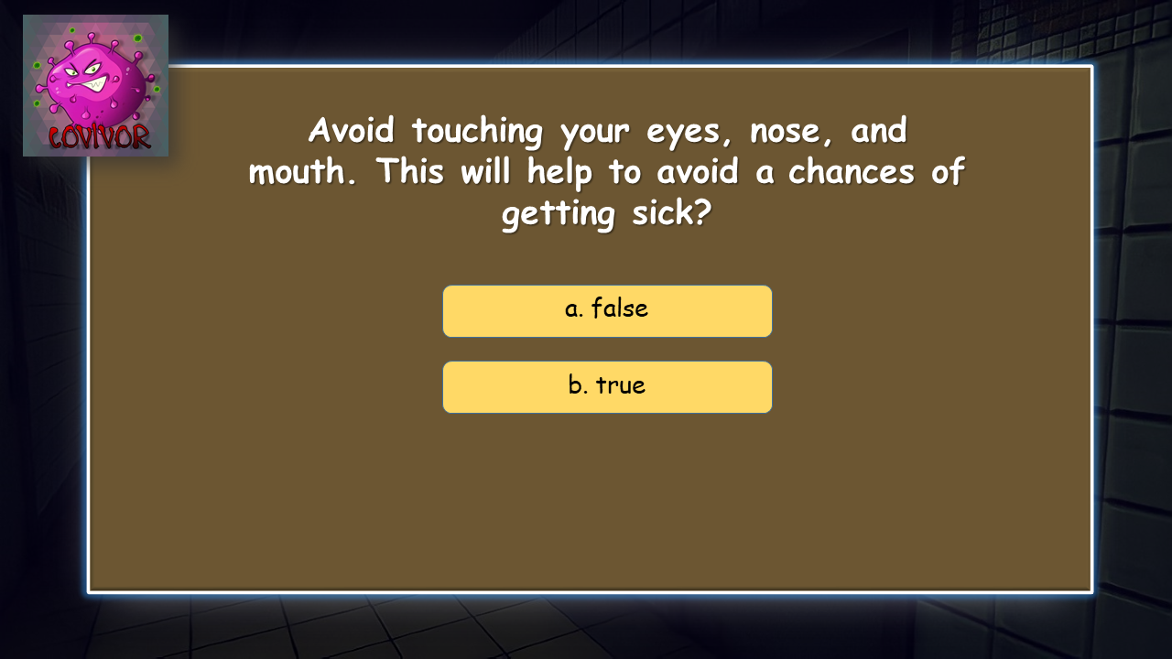

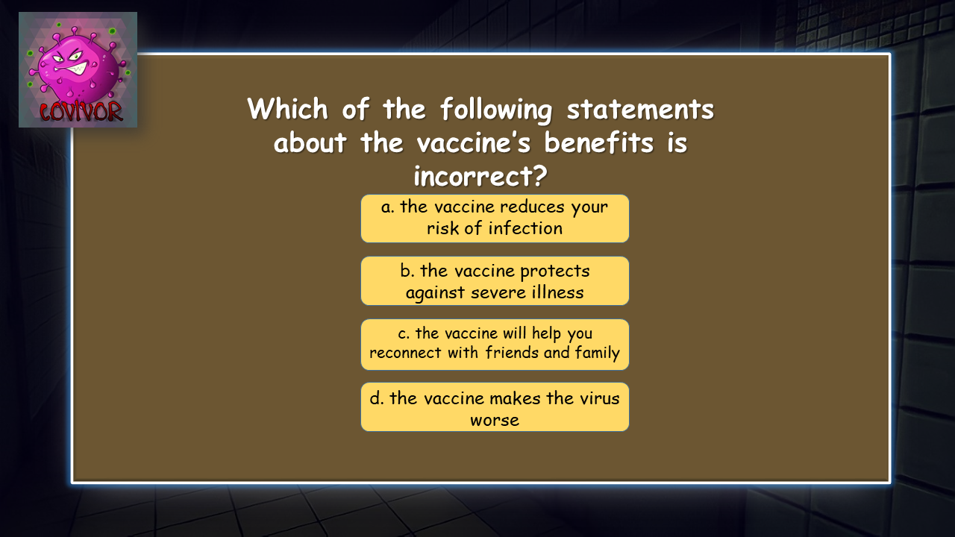

**NEXT**

**NEXT**

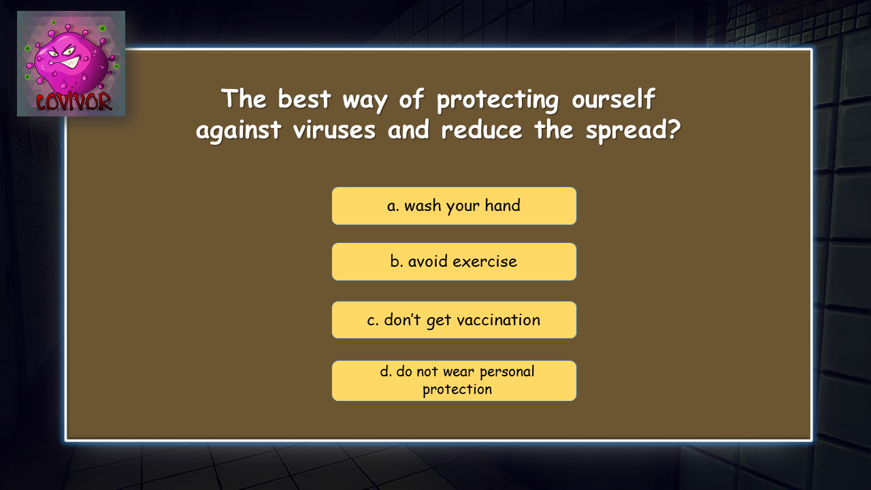

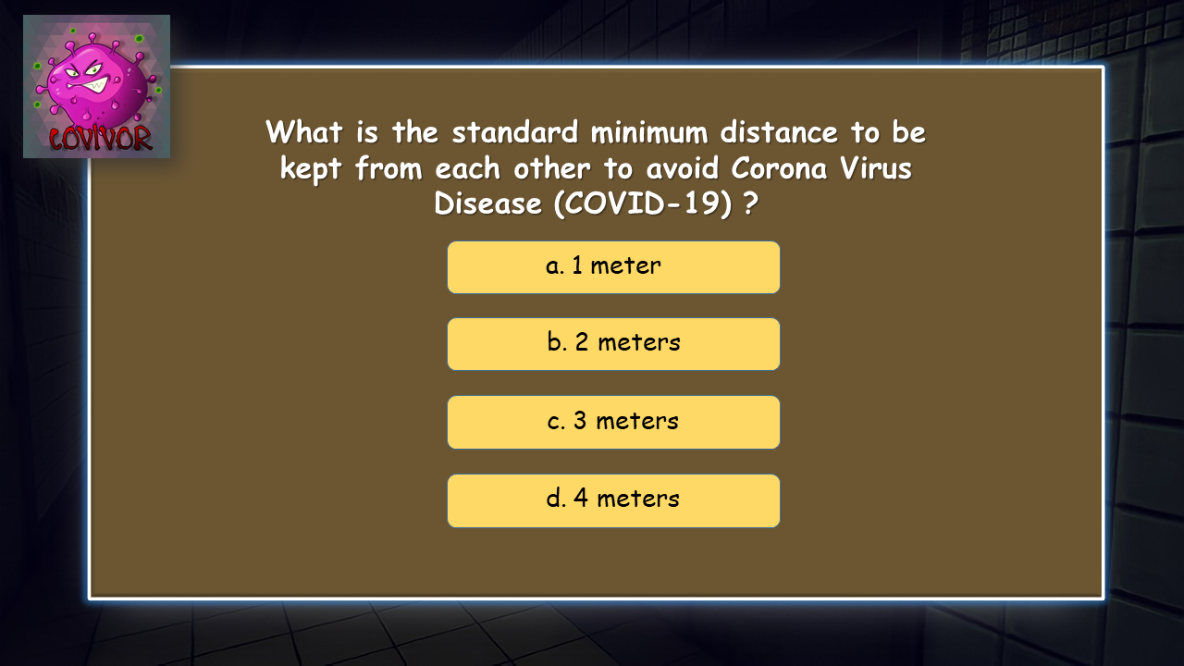

**NEXT**

****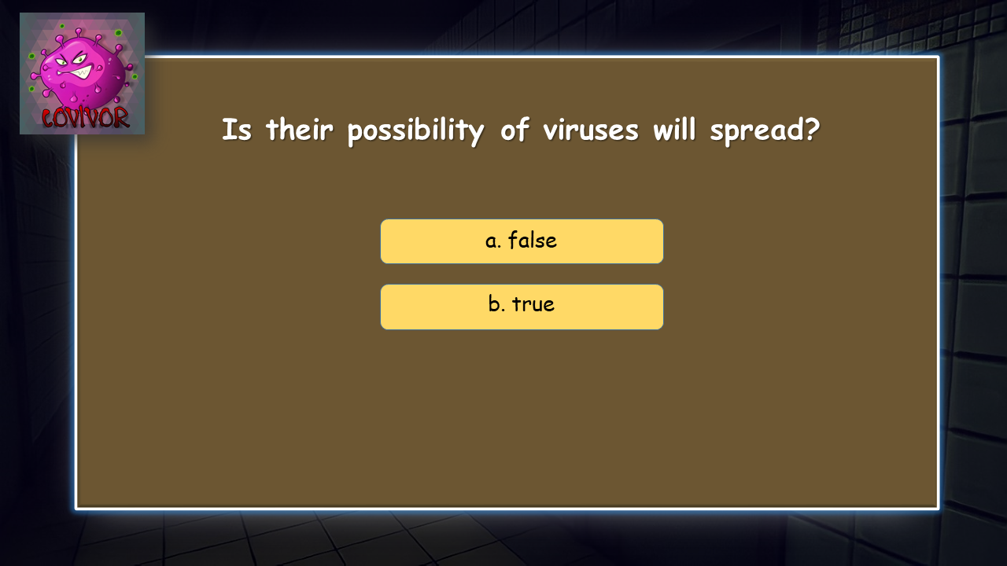

**FINISH**

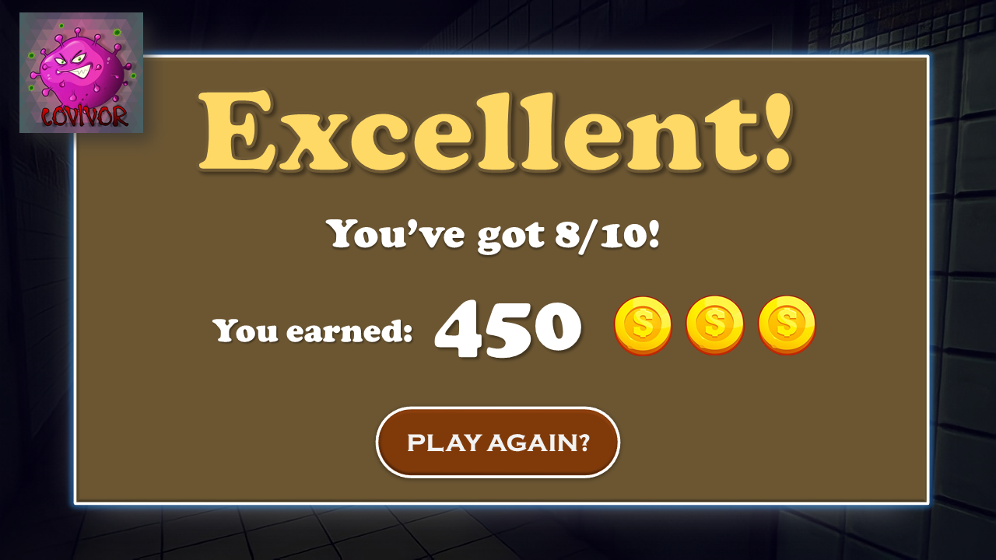

**Group Members:**

Abdullah, Nurullajie S. - Contribute ideas

Bagundang, Zarah Mae G. - Commentator

Daud, Sitty Nor-Shaina D. - Contribute ideas and assistant editor

Mancao, Nicole Haylynn G. - Conceptualized the flow and design of the game. Lead editor of the group